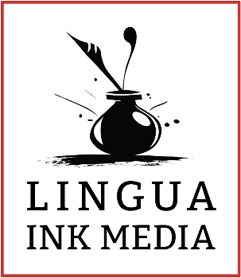
Steph Bairey
Creative Director, Lingua Ink Media
10350 N Vancouver Way, Suite 5518
Portland, Oregon 97217
(503) 847-9860
https://linguaink.com

Date

RE

To

Body Copy

Signoff,
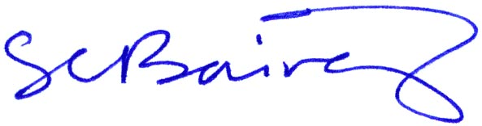

Steph Bairey

